Software Requirements Specification

Elmer Pre-Clinical Laboratory Information management system
UCD

DOCUMENT REVISION HISTORY
Version Number | Date | Description
1.0 | March 2006 | - Draft
1.1 | October 2006 | - Final

Background/Summary
The NCI Mouse Models of Human Cancers Consortium (MMHCC) has been given the task of studying and validating mouse models of human cancers.
In preparation for pre-clinical trials, a Pre-clinical Trials Working Group was appointed by the MMHCC II Informatics Committee and tasked with developing a Pre-Clinical Trials Data Assessment Survey which showed that the majority of the laboratories did not store their data in a retrievable digital format. The Pre-Clinical Trials Data Assessment Survey clearly showed that the majority of the MMHCC II-related laboratories do not have the necessary infrastructure to adequately store, retrieve and display the trials data in an electronic format. To remedy these infrastructure flaws, we are creating the MMHCC Preclinical laboratory information management system.
- The system will:
  - Tracking individual mice through linkage with existing colony management systems
  - Track individual studies, and experiments, experimental data
  - accurately model different types of data sets collected in studies.
- Facilitate the sharing of experimental data by making data models available to the caBIG community via the caGrid.
- Facilitate the sharing of experimental study protocols by making data models available via the caGrid.

Table of Content

Software Requirements Specification 1
Elmer Pre-Clinical Laboratory Information management system 1
Background/Summary 1
1 Introduction 6
1.1 Overview 6
1.2 Related Documents 6
2 Actors and Goals 6
3 Use Cases 7
1.3 Primary Use Cases 7
1.3.1 Use Case Model 7
1.3.2 Brief Description 7
1.3.3 Primary Actor 8
1.3.4 Secondary Actors 8
1.3.5 Preconditions 8
1.3.6 Basic Flow of Events 8
1.3.7 Postconditions 8
1.3.8 Special Requirements 8
1.4 Manage Studies 8
1.4.1 Use Case Model 9
1.4.2 Brief Description 9
1.4.3 Primary Actor 9
1.4.4 Secondary Actors 9
1.4.5 Preconditions 9
1.4.6 Basic Flow of Events 10
1.4.7 Postconditions 11
1.4.7.1 Ready for Experiment management 11
1.4.7.2 Ready for protocol management 11
1.4.8 Special Requirements 11
1.5 Manage Experiments 11
1.5.1 Use Case Model 11
1.5.2 Brief Description 12
1.5.3 Primary Actor 12
1.5.4 Secondary Actors 12
1.5.5 Preconditions 12
1.5.5.1 Precondition Study 12
1.5.6 Basic Flow of Events 12
1.5.7 Postconditions 13
1.5.7.1 Postcondition ready for data 13
1.5.8 Special Requirements 13
1.6 Manage Protocols 13
1.6.1 Use Case Model 13
1.6.2 Brief Description 14
1.6.3 Primary Actor 14
1.6.4 Secondary Actors 14
1.6.5 Preconditions 14
1.6.6 Basic Flow of Events 14
1.6.7 Postconditions 15
1.6.7.1 Postcondition ready to associate with experiments 15
1.6.8 Special Requirements 15
1.7 Use Experiments 16
1.7.1 Use Case Model 16
1.7.2 Brief Description 16
1.7.3 Primary Actor 16
1.7.4 Secondary Actors 16
1.7.5 Preconditions 16
1.7.5.1 Preconditions Animals. 17
1.7.5.2 Preconditions Cohorts. 17
1.7.5.3 Precondition Experiments. 17
1.7.5.4 Precondition Protocols. 17
1.7.6 Basic Flow of Events 17
1.7.7 Postconditions 17
1.7.7.1 Ready for additional data 17
1.7.8 Special Requirements 17
4 Overall Requirements 18
1.8 Requirements Prioritization 18
5 Data Definitions 18
6 Sign Off 19
1.9 Approval 19

Introduction

Overview
In preparation for the rapamycin preclinical trials, the MMHCC II discovered that the majority of the participating scientists did not have an integrated data management system. The realization that experimental animal data management was not available has prompted the MMHCC to fund the development of caElmer. caElmer fits nicely into the caBIG mission as it will provide a link between preclinical animal data and bed side clinical data.

Related Documents

Actors and Goals
Users:
Primary users of the system are those individuals who will be interacting with the system directly, and entering data into the system.

Primary Investigators:
Users with advanced rights. Primary investigator are expected to:
- define studies
- define experiments:
- define data elements
- define data protocols
- associate protocols with studies and experiments
These individual may or may not be responsible for entering / generating data, they have access to all data within their set of studies. Additionally primary investigators will be responsible for uploading / pushing data from the local application of a caBIG data node.

Data Creators:
Primarily responsible for data creation and entry. They will link animals (either obtained from a colony management system, or entered directly) to experimental cohorts, and record data from animals as defined by the protocols

Use Cases
[Repeat sections 3.X for each Use Case]

Primary Use Cases

Use Case Model
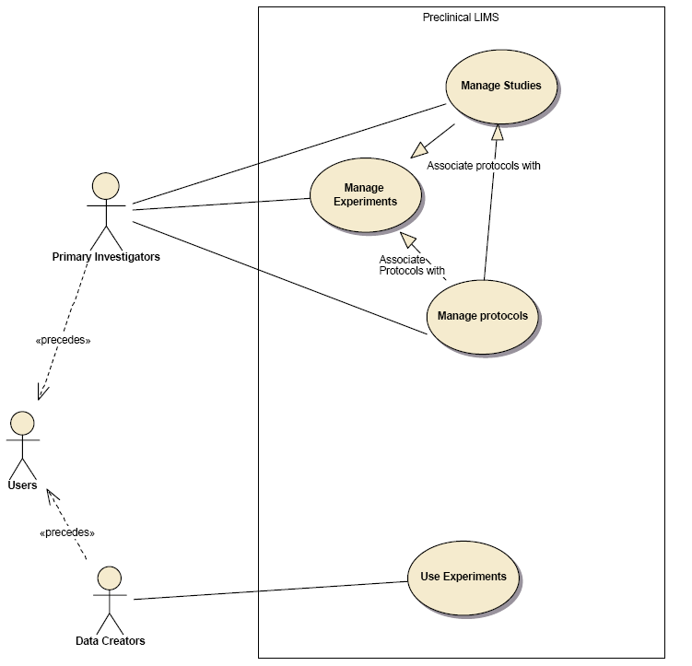

Brief Description
The primary use case describes the overview use of caElmer. It depicts the primary users interacting with the main use cases and illustrates their relationship to one another.

Primary Actor
The primary actor is this use case is the USER.

Secondary Actors
Secondary actors include both of the actors derived from the primary actor, Principle investigators and data creators.

Preconditions
None

Basic Flow of Events
Please see more detailed flow of events for each use case that detailed below

Postconditions
Please see individual use cases below

Special Requirements
Please see individual use cases below

Manage Studies

Use Case Model
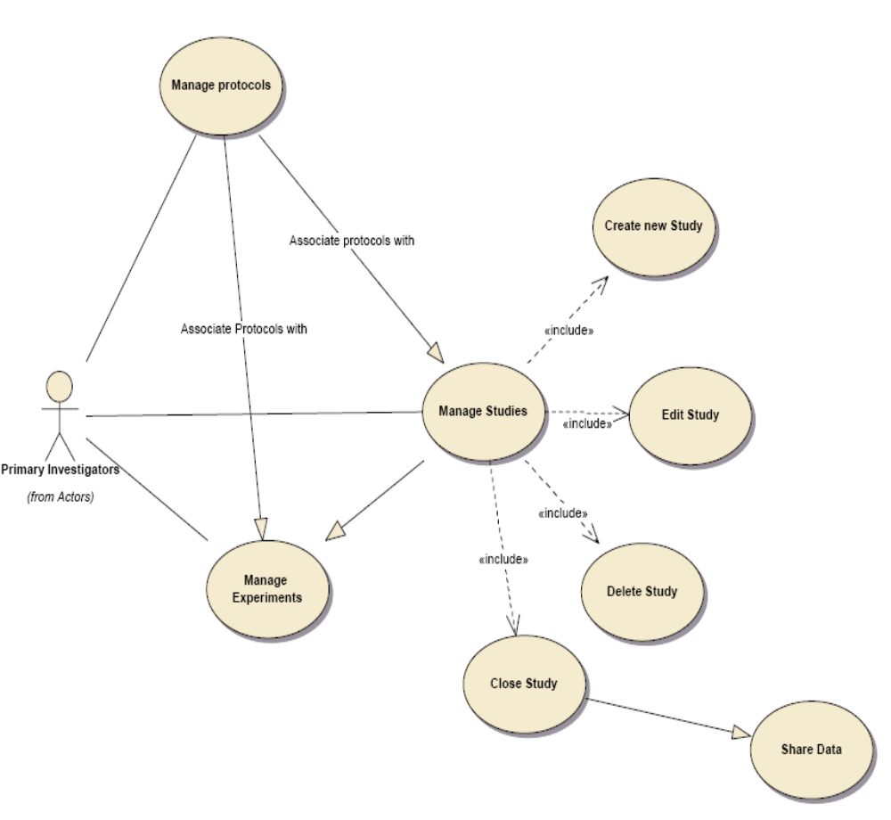

Brief Description
Manage Studies. The manage study use case illustrates how studies are managed within caElmer. Study management is broken into several tasks as illustrated by the diagram. Study initiation is the starting point for any related group of experiments, and because no experimental data can exist without belonging to a study, this is one of the most important activities within caElmer.

Primary Actor
The primary actor for this use case is the primary investigator (PI).

Secondary Actors
None.

Preconditions
- Study initiation: none. New studies may be created at any time from within caElmer.
- Edit,deleting and closing studies: To edit delete or close an existing study first the study must exist and second the (PI) must be an owner of the study in question. PI's may only manage their own studies and may not manage other PI's studies.

Basic Flow of Events
PI: Create a new study
System: Enter study parameters:
Hypothesis
The hypothesis is a statement which describes the goal of the study in the form a testable assertion.
Start date
The date for the start of the study
caModles, Gene,
Study attribues which are obtained form cdBio databases used to identify and catagorize studies
protocols
experimental data models used to collect experimental data for within a study
PI: Edit a study
System: check does PI have permission to edit requested study?
Yes – allow PI to make changes to fields defining study
No – Display alert telling PI that they do not have sufficient permission to edit requested study
PI: Delete study
System: check does PI have permission to delete requested study?
Yes – mark study and all associated experimental data as deleted. Note deletion will not actually delete data simply hide it from view. Deleted data may be retrieved via direct access to the caELMIR database
PI: Close study:
System: Check does PI have permission to close study?
Yes – Check to see if all linked experiments have been completed. If some experiments are currently open, warn PI that some experiments are currently open and confirm that they will be closed if study is closed
No – Display alert telling PI that they do not have sufficient permission to close study.
Once a study has been closed the system will offer the PI the opportunity to make the study data available to the caGrid via a grid service.

Postconditions

Ready for Experiment management
After the PI has finished managing the studies the system will be ready for experimental management. Researchers will now be able to add or edit experiments.

Ready for protocol management
After the PI has finished managing the studies the system will be ready for protocol management. Researchers will be able to add and or edit protocols as well as associate them them studies and experiments.

Special Requirements
N/A

Manage Experiments

Use Case Model
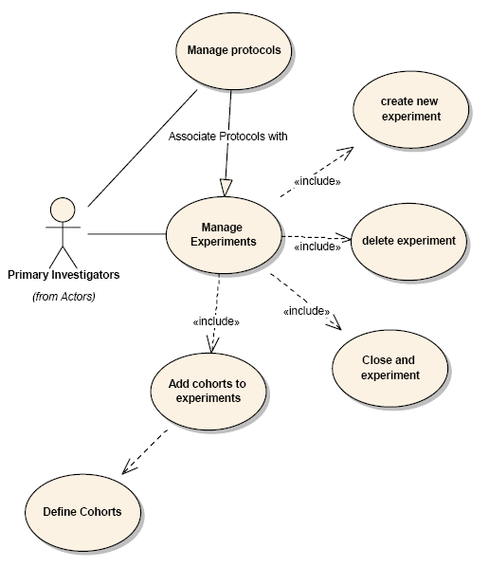

Brief Description
Manage experiments. The manage experiments use case illustrates how primary investigators can interact with experiments. Briefly Pi's can create, edit and delete experiments.

Primary Actor
The primary actor is the primary investigator.

Secondary Actors
We do not envision any secondary actors

Preconditions
The presence of an appropriate study to assign the experiment to, and data protocols.

Precondition Study
Appropriate study to associate experiment with.

Basic Flow of Events
PI: Create a new experiment
System: Enter study parameters:
Hypothesis
Hypothesis detailing what this experiment is intended to show
Start date
Start date for the experiment
protocols
Either associate or create protocols for data collection.
PI: Edit an experiment
System: check does PI have permission to edit requested experiment?
Yes – allow PI to make changes to fields defining experiment
No – Display alert telling PI that they do not have sufficient permission to edit requested experiment
PI: Delete experiment
System: check does PI have permission to delete requested experiment?
Yes – mark experiment and all associated experimental data as deleted. Note deletion does not delete data, elements marked as deleted are hidden from view
PI: Close experiment:
System: Check does PI have permission to close experiment?
Yes – Mark experiment as closed, do not allow any further data to be added to the experiment.
No – Display alert telling PI that they do not have sufficient permission to close experiment.
PI: Define experimental cohorts:
All animals must belong to an experimental cohort, therefore, for experimental data to be added to an experiment, the animals from which the data is obtained from must belong to a cohort
System: Enter Cohort parameters:
cohort name
experimental condition which defines the cohort

Postconditions
N/A

Postcondition ready for data
Once experiments have been defined the system is in a state where experimental data can be entered.

Special Requirements
N/A

Manage Protocols

Use Case Model
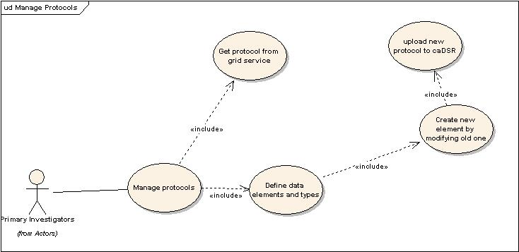

Brief Description
Manage protocols. The manage protocols use case allows PI's to define and associate experimental protocols. Experimental protocols formally define experimental data elements or data models, dictating the element, its units and the mechanism used to capture the data. Similar types of data elements may utilize multiple protocols if there are multiple methods for capturing the data element. For example, Tumor size may be represented either as gross measurement utilizing calipers, or an estimate based on the major and minor aspects as measured on a microscope slide, or as a volume rendered from a diagnostic imaging study. Multiple protocols may be associated with a given experiment.

Primary Actor
The primary actor is the PI. It is not envisioned that additional actors will be defining data elements for a given study or experiment.

Secondary Actors
None

Preconditions
None. Protocols since they can be used with a variety of studies and experiments can be defined independent of any study or experiment.

Basic Flow of Events
PI: Define a new protocol
System: Is there a protocol already defined which can be modified to create the new element?
Yes – Load old protocol for editing and saving as new element
No
1) Search caElmir protocol service for protocols which match the current data model. If an appropriate protocol model is found, download and install the data model via the caELMIR service.
2) Define all elements needed to aquatically define the unique data element. Once a new protocol has been defined, upload the data model to the caDSR, and make the model available via the caGrid.
Protocols need to be able to define a variable number of element, including one or more basic data types, the unites associated with the data and the methodology used to collect the data. It is import to associate the data collection with the method used to collect the data. The reason for this is that seemingly similar data types may in fact be very different if they are collected in a manner which precludes the data types being directly compared.

Postconditions

Postcondition ready to associate with experiments
Once a protocol is defined it may be associated with an experiment. Protocols may be associated with one or more studies and experiments.

Special Requirements
None

Use Experiments

Use Case Model
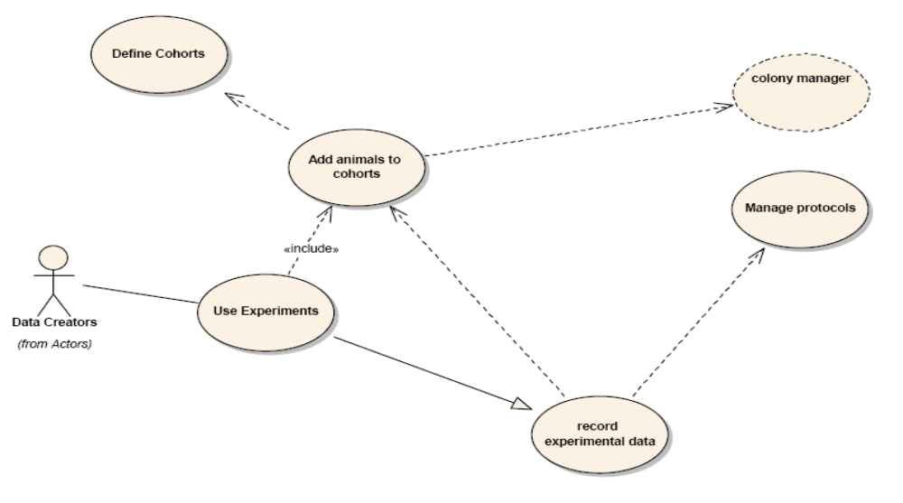

Brief Description
Use Experiments. The use experiments use case details how users or data creators interact with the system to add data to an experiment.

Primary Actor
The primary actor is the Data Creators. These are the individuals which are responsible for generating experimental data. Physically this individual may the same or different from the PI who defined the experiment, but is envisioned to be a different person.

Secondary Actors
None

Preconditions
For data to be collected a number of elements must be in place including those listed below.

Preconditions Animals.
Animals to collect data from must exist. In addition to unequally identify the animals, they must already be managed within a separate animal colony management system. Links between the colony management system and this system will have to be built so that important animal demographic information can readily obtained.

Preconditions Cohorts.
Cohorts must be defied for animals to be linked to. All animals must belong to a cohort defining its role within a given experiment.

Precondition Experiments.
For data to be generated an experiment must be defined.

Precondition Protocols.
Data protocols must be defined and linked to an experiment for data to be added to the experiment.

Basic Flow of Events
Data collector: I have data to enter into the system
System: Select a Study , experiment and cohort to enter data into
System: Select the experimental animal to enter data for,
System: Select the appropriate protocol which represents the data to be entered
System: Enter data
Data collector: entering data into the system

Postconditions

Ready for additional data
Once data has been entered the system will be ready to receive additional data

Special Requirements
None

Overall Requirements

Requirements Prioritization

Priority | Use Case Name | Supp Requirement Ref #
<Comments>

Data Definitions
Animal Id – a unique number which identifies an animal within a given laboratory. Usually this will be an ear tag, toe clipping ear notch or some other form of identifying an animal within an experimental system. These number are considered unique for only a limited time frame, and only within a given laboratory.
UAI – Universal animal ID, this is unique id given to an animal by the system and will be unique across the entire caElmer system such that data integrity can be maintained.
Protocol – a unique set of parameters which identifies a give experimental data type. The protocol needs to define the data type, its unit of measurement and how the data is collected. Data collection will generally be in the form of linked SOP's
SOP – Standard operating procedure. Procedures used in a lab to conduct experiments.
Hypothesis – a statement detailing what is being accomplished by a give study or experiment.
Study – a collection of experiments
Experiment – a manipulation designed to show whether a condition can be satisfied or not satisfied.

Sign Off

Approval

Workspace General Contractor Rep Print Name Date
Architecture Workspace Rep Print Name Date
VCDE Workspace Rep Print Name Date
Workspace Working Group Rep Print Name Date
NCICB Rep Print Name Date

